Year 6 Duxford Trip
Our Year 6 trip to Duxford Imperial War Museum was a fantastic day, and the children thoroughly enjoyed the experience. Throughout the visit, the children demonstrated excellent behaviour and represented the school extremely well. They listened carefully to instructions, stayed with their groups and showed respect for both the museum, its exhibits and the members of the public around them.
One of the highlights of the day was having the opportunity to observe the pre-air show practice. The children were fascinated by the aircraft as they watched them take to the skies and enjoyed seeing some of the impressive manoeuvres. There was a real sense of excitement as the children watched and listened, and it was wonderful to see their enthusiasm and curiosity throughout the experience.
The children also enjoyed exploring the many exhibits at Duxford. They were particularly interested in seeing the historic aircraft and learning more about their roles in different periods of history. Many children asked thoughtful questions and enjoyed discussing the things they had discovered with their friends and teachers.
Overall, it was a very successful and enjoyable trip. The children’s behaviour was brilliant from beginning to end, and they showed great enthusiasm for their learning outside the classroom. It was lovely to see them having fun while also developing their understanding of history and the significance of the exhibits they encountered. A big well done to Year 6 for making the day such a positive and memorable experience!
The Year 6 Team

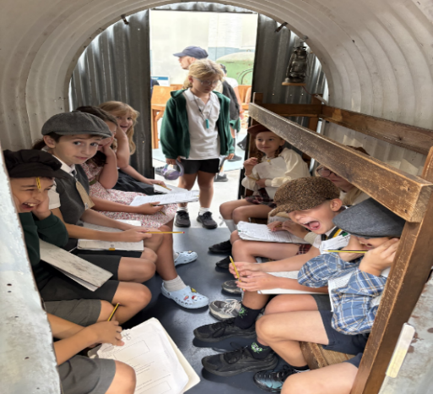
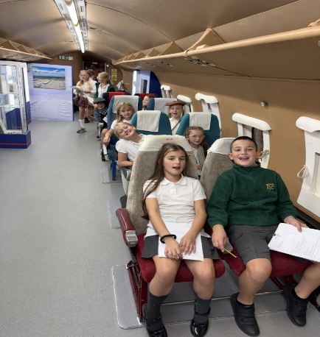
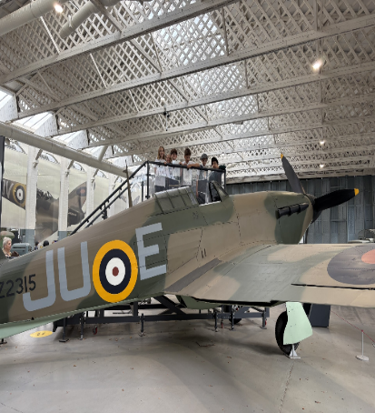

Children’s Parliament
Our six Children’s Parliament candidates from last year were invited to Chelmsford County Hall this week to learn more about democracy and the rules of Parliamentary debate. They also enjoyed a unique training session with former BBC and Sky News journalist Sharon Evans on how to present an argument and public speaking before taking part in a debate themselves.
In a remarkable achievement, Hugo Karczewski was elected the new Child Chancellor of the Exchequer.
On Wednesday, Olivia White, Hugo Karczewski and Daisy Davenport attended a special reception at the House of Lords to celebrate and support the Sir David Amess Children’s Parliament UK. Guests from Parliament, business, education, media and philanthropy alike were impressed by our three representatives as well as Fairways’ work to promote British values of democracy, rule of law, mutual respect, tolerance, mutual respect and individual liberty.
Olivia, Hugo and Daisy are now looking forward to 15 October when 100 primary-aged children from across all four nations of the UK will come together for a 90-minute, child-led debate in Parliament, opened by the Speaker of the House of Lords, Lord Forsyth of Drumlean.
From the parents who were on the trip
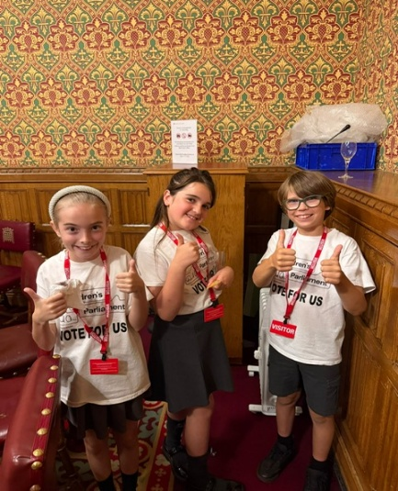
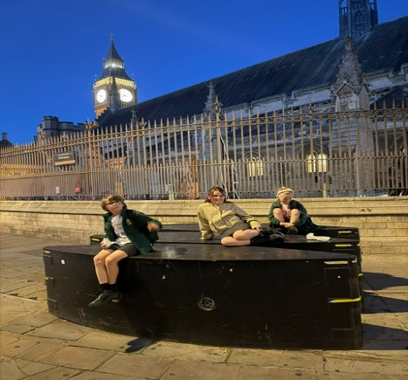
‘The kids did absolutely amazing and it was an incredible confidence-building experience for them. Thank you to Mr Turner for being such a great support to the children (and us parents!).’
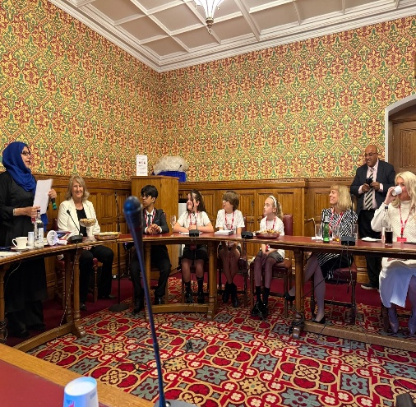

Achievements in school
Eliza Hardy for her interest and enthusiasm in history
Savanna Kelly for her hard work and focus in maths
Henry Howley for being a helpful learning partner
Riley Jennings for a great mindset in lessons and completing things independently
Thabani Mabandla for an excellent, positive learning attitude
Evelyn Peasey for having a positive and hardworking attitude to all aspects of school life
Aadam Umer for making us smile and laugh this week
Louis Kollasch for lovely listening and always trying his best
Mollie Ferris for her hard work in maths and good attitude
Margot Faint for her great effort in all subjects
Storm Fincham for clear and enthusiastic pronunciation in phonic lessons
Freddie Bateman for a clear and accurate retelling of the story Esio Trot

Achievements outside of school
Zack Davenport this week he completed his 10th park-run, which is the equivalent to running a half marathon 20 km
Jessie and Molly Tyler achieved a distinction in their first ballet exam and Finley achieved first place in his gymnastics competition at South Essex gymnastics club
Lottie and Olivia Bourke completed the Summer Reading Challenge

TT Rock Stars
11th September 2026
Biggest improvement in accuracy across the whole school
1st - Annabella Carter
2nd - Arthur Kirby
3rd - Jessie Tyler
Most correct answers
1st - Freddie Selby
2nd - Lottie Bourke
3rd - Kevin Florea
Biggest improvement in studio speed
1st - Frankie Malcolm
2nd - Anika Polisani
3rd - Holly White
18th September 2026
Biggest improvement in Studio Speed
1st - Max Webb
2nd - Holly White
3rd - Kevin Florea
Most Correct Answers
1st - Lucas Saiz-West
2nd - Ryan Strychalski
3rd - Troy O'Brien
Biggest Improvement In Accuracy
1st - Annabella Carter
2nd - Ronnie Warr
3rd - Evelyn Taylor
Sports Stars
Working hard- Holly White
Considerate- Delilah Andre
Teamwork- Charlie Thompson
Setting an example- Logan Knight

Team points carried over from last week
Red – 144 points
Water – 138 points
Green – 111 points
Yellow 85 points

Attendance Matters
Good attendance is essential for children to achieve their full potential. Every day at school counts, and regular attendance supports both academic progress and wellbeing.
We closely monitor attendance and will contact parents and carers of pupils whose attendance falls below 95% to discuss how we can work together to improve attendance. At 95% attendance, a child misses approximately 10 days of learning across the school year.
We ask all parents and carers to ensure their child attends school every day unless they are genuinely unwell and to avoid taking holidays during term time.
Thank you for your support in helping every child make the most of their education.
Attendance This Week by class
Well done to all classes for their efforts this week. Regular attendance is essential for ensuring pupils achieve their full potential and make the most of every learning opportunity. Thank you to parents and carers for your continued support in helping children attend school every day and arrive on time.

Attendance Percentages
Class | Attendance
Bumblebee | 99.3%
Butterfly | 90.1%
Dragonfly | 99.6%
Fox | 96.4%
Hawk | 97.9%
Hedgehog | 98.2%
Kingfisher | 99.2%
Ladybird | 99.4%
Mole | 97.8%
Otter | 97.7%
Rabbit | 96.9%
Squirrel | 98.3%
Wildcat | 96.8%
Woodpecker | 98.1%

Highest Attendance: Dragonfly (99.6%) 🎉
Second Highest: Ladybird (99.4%)
Third Highest: Bumblebee (99.3%)
Whole School Average: 97.4%

Dates for Your Diary

Date | Event | Time
Monday 21st September | Fairways V Hockley Football Match | 3.20pm – 4.20pm
Tuesday 29th September | Reception prospective pupils September 2027 tours | 9:15am - 10:30am
Wednesday 7th October | School Photographer | 8am – 12pm
Friday 9th October | Reception prospective pupils September 2027 tours | 9:15am - 10:30am
Friday 16th October | Halloween Disco KS2 | Times TBC
Monday 12th October | Reception prospective pupils September 2027 tours | 9:15am - 10:30am
Wednesday 21st October | Reception prospective pupils September 2027 tours | 9:15am - 10:30am

Thank you for your continued support.


