Pupil and parent/carer updates
The pupils have settled well into their new classes and routines at Fairways. Staff are working hard to ensure that all pupils have a positive learning environment, with clear daily structures and appropriate adaptations to meet the needs of every learner. We want our pupils to develop positive attitudes to learning and to confidently apply their knowledge and understanding across the curriculum.
Our new Reception pupils have enjoyed exploring both the indoor and outdoor learning environments and are already becoming familiar with the routines of school life. Reception staff are working closely with the children to ensure that they feel safe, happy and secure in their new surroundings. As part of their transition into full-time education, Reception pupils will stay for lunch on Monday and Tuesday next week, helping them to gradually build confidence and settle into attending school for the full day.
Good attendance is essential for pupils to achieve their full potential and make the most of the opportunities available to them at school. We closely monitor attendance for all pupils and have established a dedicated Pastoral Team to support pupils' wellbeing, welfare and attendance needs. The Pastoral Team consists of Miss Phillips, Mr Turner, Mrs Imber, Mrs Bose and Mrs Phillips. The team meets weekly to discuss any pupils who may require additional support relating to attendance, welfare or other pastoral needs.
To further support families, a member of the Pastoral Team will be stationed near the main office each morning to monitor pupils arriving late to school. They will be available to offer support and guidance to parents and carers who may be experiencing difficulties in getting their child to school on time. Where concerns regarding attendance, welfare or pastoral support are identified, these will be discussed during the weekly Pastoral Team meetings. Parents and carers may be contacted by a member of the Pastoral Team to discuss any support that may be available for their child and family. The role of the Pastoral Team is to work alongside families in a supportive and caring manner, helping to identify and overcome any barriers that may be affecting a child's attendance, wellbeing or ability to engage fully in school life.
If parents and carers have any concerns regarding their child's attendance, wellbeing or pastoral support needs, we ask that they contact their child's class teacher in the first instance. The class teacher will work to support the issue where possible and, if further intervention is required, will refer the matter to the Pastoral Team for additional support and guidance. By working together, we can ensure that every child feels happy, safe and supported, attends school regularly and is able to thrive both academically and socially.
Next week, we will be sending information to year groups about a range of clubs available for Upper School pupils this term. These will be led by teachers and will include Choir, Maths-related Clubs, Drama and Go for Green. During the second half of the term, we will also be offering a selection of clubs for Lower School pupils. We look forward to seeing many children take advantage of these exciting opportunities.
Achievements in school
Max Watson for demonstrating our core values at all times
Aaira Khan for always following the Fairways Way
Celine Florea for outstanding learning behaviours and engagement in lessons
Barney Carey- Hulford for great enthusiasm in maths lessons this week and demonstrating gret knowledge
Sami Butt for being an excellent role model
Noah Carter for a great focus, effort and participation in class
Hunter Gill for his fantastic attitude to learning and hard work
Elodie Ferris for always demonstrating our school rules
Emily Froydenlund for an amazing effort in all lessons and being so helpful

Achievements outside of school
Jorge Paprota for obtaining a place in the ice hockey academy
Congratulations to Elodie and Mollie Ferris for taking part in the Big Summer Read Challenge and for their fantastic fundraising efforts in support of Neptune Ward at Southend Hospital.
During August, Elodie and Mollie organised a sponsored danceathon with some of their friends. Despite the very hot conditions, they danced for an incredible two hours and raised a fantastic £835.
Last Friday, they visited the hospital with their family to present the donation to the nurses and members of the play team on Neptune Ward. We are incredibly proud of their determination, generosity and commitment to helping others. They have shown our school values in action and are wonderful role models for the Fairways community.
Well done, Elodie and Mollie, on this outstanding achievement and for making such a positive difference to the children and families supported by Neptune Ward.

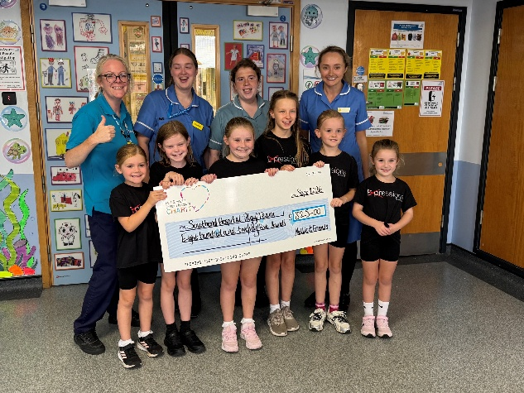

Jax Martin for gaining a trophy for athlete of the week in athletics
Isabella Warwick for passing her ballet exam with distinction and gaining her red rosette in her freestyle dance exam
Marnie Mchugh and Jaxon McHugh for completing the Summer Reading Challenge
Marnie McHugh for passing her exams in musical theatre and commercial dancing

TT Rock Stars – carried over to next week
Sports Stars
Working hard- Luna Brown
Setting an example- Harrison Vale
Considerate- Arthur Kirby
Teamwork- Isabella Burgess

Attendance Matters
Good attendance is essential for children to achieve their full potential. Every day at school counts, and regular attendance supports both academic progress and wellbeing.
We closely monitor attendance and will contact parents and carers of pupils whose attendance falls below 95% to discuss how we can work together to improve attendance. At 95% attendance, a child misses approximately 10 days of learning across the school year.
We ask all parents and carers to ensure their child attends school every day unless they are genuinely unwell and to avoid taking holidays during term time.
Thank you for your support in helping every child make the most of their education.

Attendance This Week by class
Bumblebee | Butterfly |  | Dragonfly | Fox | Hawk | Hedgehog | Kingfisher
99.1% | 90.2% |  | 99.6% | 98.3% | 97.8% | 98.8% | 98.6%
Ladybird | Mole | Otter | Rabbit | Squirrel | Wildcat | Woodpecker
100.0% | 96.7% | 99.4% | 97.7% | 99.0% | 96.7% | 97.5%
Attendance Champion: Ladybird Class - 100%
Well done to all classes for their efforts this week. Regular attendance is essential for ensuring pupils achieve their full potential and make the most of every learning opportunity. Thank you to parents and carers for your continued support in helping children attend school every day and arrive on time.

